Experiment 7

1. AIM:
To integrate advanced analytics with Business Intelligence reports using Microsoft Power BI and generate business insights, strategic recommendations, and executive presentations that support organizational decision-making.
2. OBJECTIVE:
- To analyze existing Power BI reports and dashboards for evaluating organizational performance.
- To identify business strengths, weaknesses, and opportunities through data analysis.
- To perform regional, product category, customer segment, and sales trend analysis.

3. TOOLS / SOFTWARE REQUIREMENT
- Microsoft Power BI Desktop
- Global Superstore Dataset.xlsx
- Power Query Editor
- Microsoft PowerPoint
4. DATASET SOURCE: Global Superstore Dataset (Kaggle)
5. THEORY:
Advanced Analytics in Business Intelligence focuses on transforming data into actionable insights. While traditional BI reports present information, advanced analytics helps identify trends, opportunities, business challenges, and improvement areas. Organizations use analytical reports and dashboards to support strategic planning and decision-making.
Power BI enables advanced analytics through KPI analysis, trend analysis, comparative analysis, ranking, segmentation, and interactive reporting. The ultimate objective is to convert analytical findings into meaningful business recommendations.

Business Scenario
Global Superstore management has observed that sales are increasing but profitability is not growing at the expected rate. Senior management requires an analytical review of business performance. Students will act as Business Intelligence Consultants and use Power BI reports and dashboards to identify issues, discover opportunities, and recommend corrective actions.
6. PROCEDURE:

Part A: Analyze Existing Reports and Dashboards

Step 1: Open the Existing Power BI Reports and Dashboards

How to perform:
- Open Microsoft Power BI Desktop.
- Open the Experiment_7.pbix file created using Save As from Experiment 6.
- Review the existing report pages and visualizations.
- Examine the Executive Dashboard created in Experiment 6.
- Review the Business Performance Scorecard.
- Identify the available KPI cards, charts, tables, and slicers.
- Create a new report page using the (+) icon at the bottom.
- Rename the page as Regional Analysis.
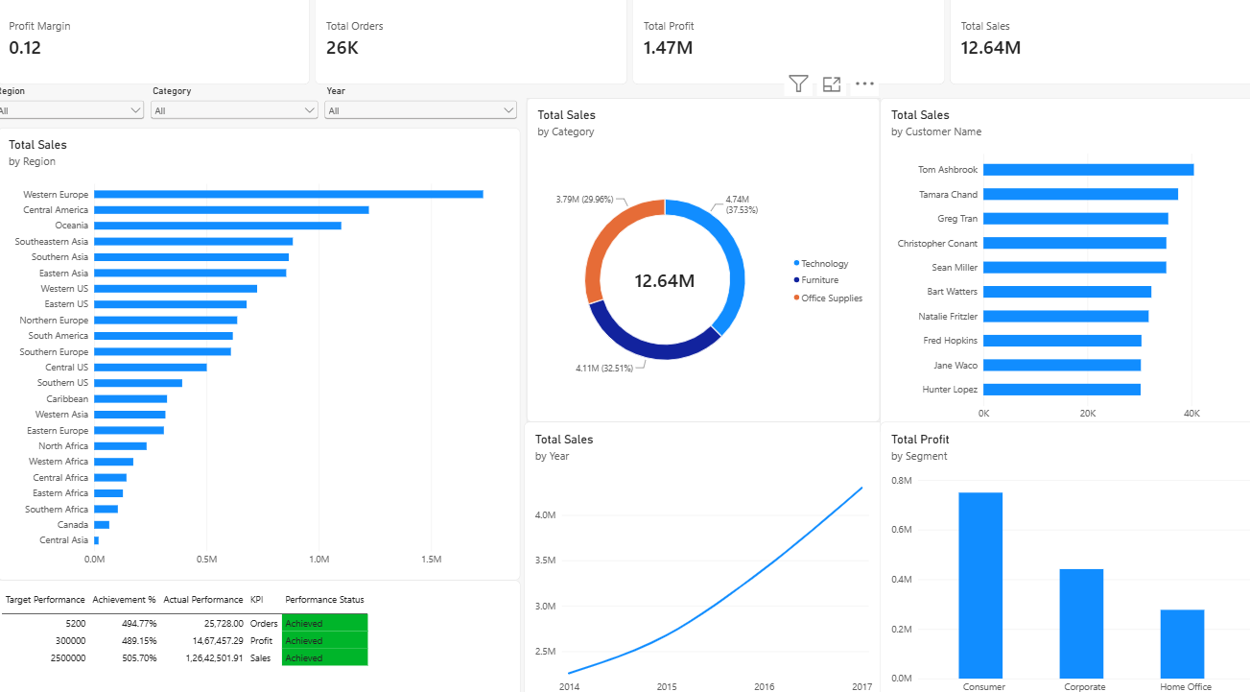

Step 2: Analyze Sales Performance by Region
How to perform:
- Open your Experiment 5 or Experiment 6 Power BI report.
- Go to the report page where you want to create the chart.
- Click an empty area of the report canvas.
- Open the Visualizations pane.
- Select Clustered Bar Chart.
- From the Data pane, drag Region into the Y-axis.
- Drag Sales into the X-axis.
- Click the three dots on the chart.
- Select Sort by → Sales → Descending.
- Open Format Visual and enable the chart title.
- Set the title to Sales Performance by Region.

Step 2: Analyze Sales Performance by Region.
How to perform:
- Open the Regional Analysis page.
- Click an empty area of the report canvas.
- Open the Visualizations pane.
- Select Clustered Bar Chart.
- From the Data pane, drag Region into the Y-axis.
- Drag Sales into the X-axis.
- Ensure Sales aggregation is set to Sum.
- Click the three dots (...) on the chart.
- Select Sort by → Sales → Descending.
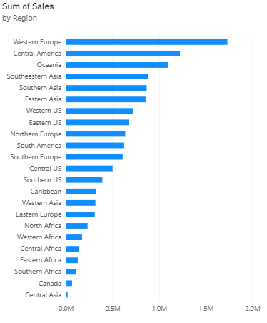

Step 3: Analyze Profitability by Product Category
How to perform:
- Click an empty area of the report canvas.
- Select Clustered Column Chart from Visualizations.
- Drag Category into the X-axis.
- Drag Profit into the Y-axis.
- Ensure Profit aggregation is set to Sum.
- Open Format Visual.
- Enable the Title option.
- Enter Profitability by Product Category.
- Compare the profitability of Furniture, Office Supplies, and Technology.
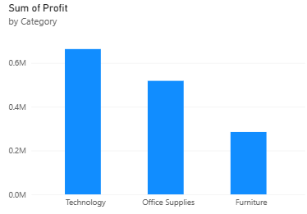

Step 4: Analyze Customer Segment Performance
How to perform:
- Select Clustered Column Chart.
- Drag Segment into the X-axis.
- Drag Sales into the Y-axis.
- Ensure aggregation is set to Sum.
- Set the chart title to Sales by Customer Segment.
- Create another Clustered Column Chart.
- Drag Segment into the X-axis.
- Drag Profit into the Y-axis.
- Compare Consumer, Corporate, and Home Office segments.
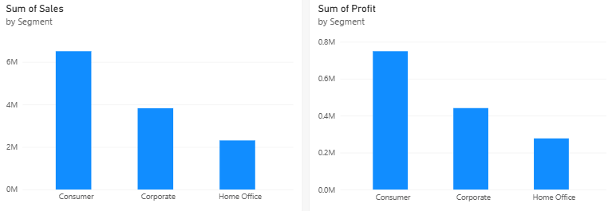

Step 5: Analyze Monthly and Yearly Sales Trends
How to perform:
- Click an empty area of the report canvas.
- Select Line Chart from Visualizations.
- Drag Order Date into the X-axis.
- Select Date Hierarchy from the field dropdown.
- Use the Year and Month levels for time-based analysis.
- Drag Sales into the Y-axis.
- Ensure aggregation is set to Sum.
- Open Format Visual.
- Enable the Title option.
- Enter Monthly and Yearly Sales Trends.
- Examine the sales fluctuations and identify peak sales periods.
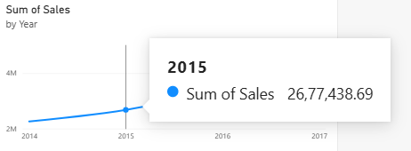

Part B: Business Problem Identification

Step 6: Identify Business Strengths
How to perform:
- Review the Sales Performance by Region chart.
- Identify the regions generating the highest sales.
- Review the Profitability by Product Category chart.
- Identify the categories generating higher profits.
- Review the Customer Segment charts.
- Identify the customer segments contributing significantly to sales and profit.
- Record at least two business strengths based on the analytical findings.
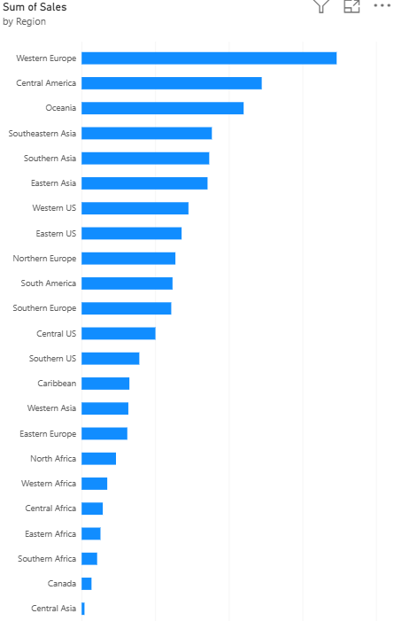

Step 7: Identify Business Weaknesses
How to perform:
- Review the Profit by Category chart.
- Identify categories or sub-categories with low or negative profits.
- Compare sales and profit performance.
- Identify regions generating high sales but relatively low profits.
- Examine customer segments with comparatively lower profitability.
- Record at least two business weaknesses.
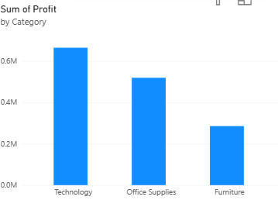

Step 8: Identify Business Opportunities
How to perform:
- Identify high-performing geographical regions.
- Examine profitable product categories.
- Analyze customer segments with growth potential.
- Review monthly and yearly sales trends.
- Identify opportunities to improve sales and profitability.
- Record at least two business opportunities.
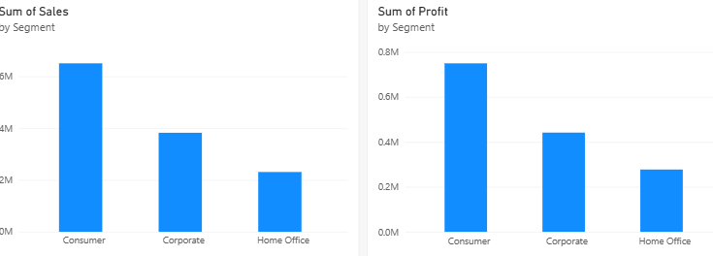

Step 9: Support Findings Using KPIs and Charts
How to perform:
- Open the Executive Dashboard from Experiment 6.
- Review the Total Sales KPI card.
- Review the Total Profit KPI card.
- Review the Total Orders KPI card.
- Open the Business Performance Scorecard.
- Examine Achievement Percentage and Performance Status.
- Compare the KPI values with the findings from previous steps.
- Record the actual values as supporting evidence.
Step 10: Final Reports
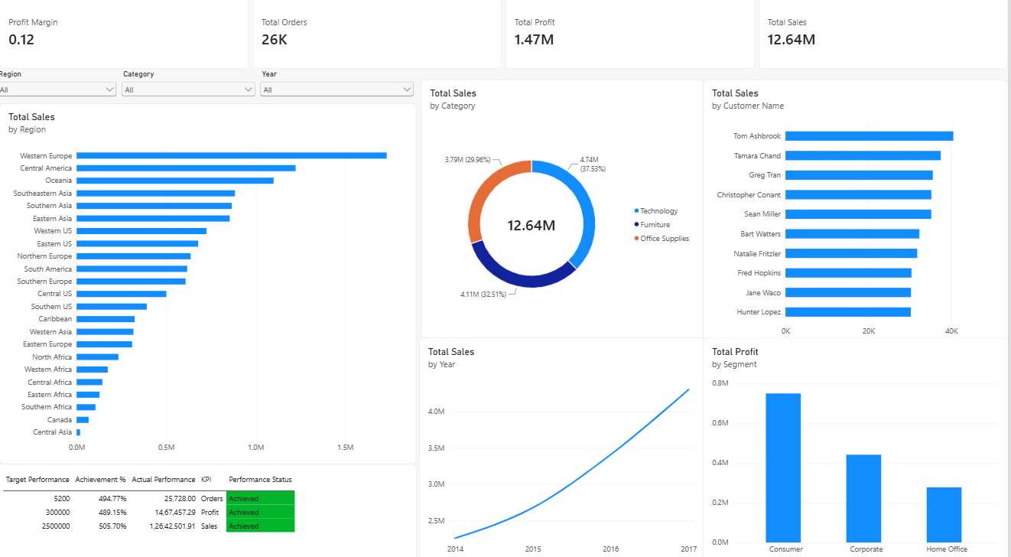
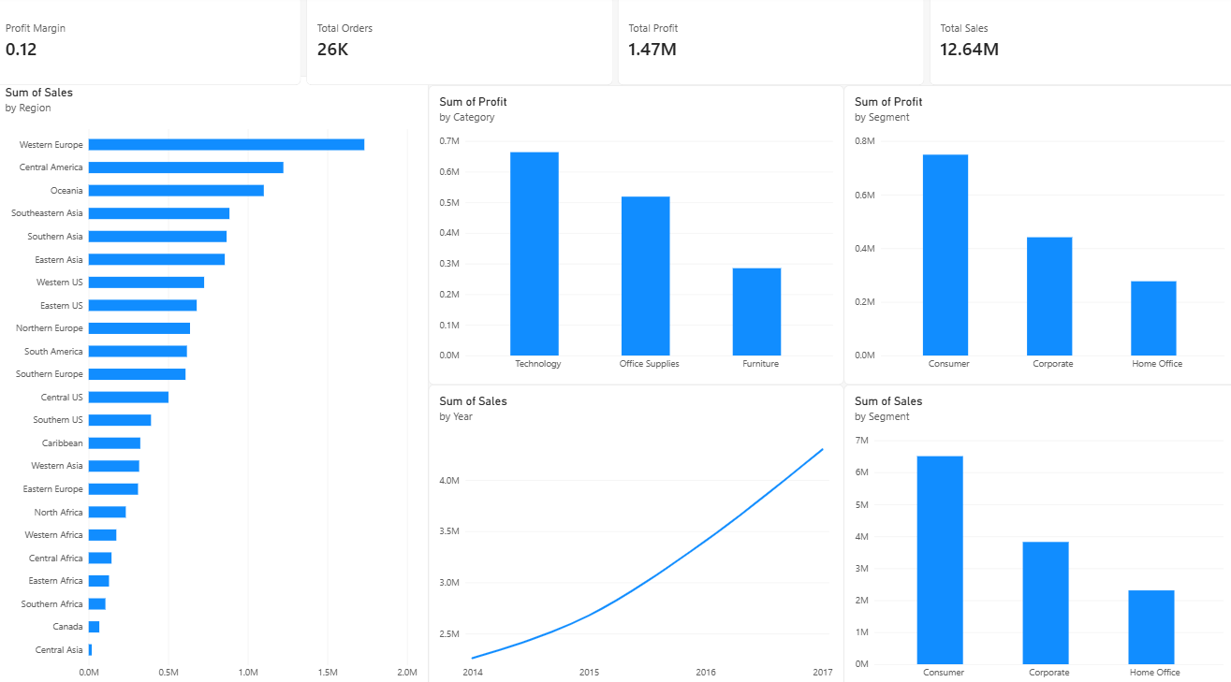

Result
Advanced analytics techniques were successfully integrated with Business Intelligence reports and dashboards. Business strengths, weaknesses, opportunities, and recommendations were identified and communicated through a professional report and executive presentation.

Learning Outcomes
• Apply advanced analytical techniques to business reports and dashboards. (CO3-BT3)
• Analyze organizational performance using BI tools and KPIs. (CO3-BT4)
• Generate business insights from analytical findings. (CO5-BT6)

